* 1. **Fractional double term zero**

Fractional zero transfer function is given by $T(s$) = $s^{α+β}+a_{1}s^{α}+a_{2}…$……(13)

Put s = jω, in equation (13) results into $T(jω$) = ${jω}^{α+β}+a_{1}{(jω)}^{α}+a_{2}$………(14)

Magnitude in dB is given by

|)| dB =20log $\sqrt{ω^{2\left(α+β\right)}+a_{1}^{2}ω^{α}+a_{2}^{2}+2a_{1}ω^{2α+β}\cos{\frac{πβ}{2}+2a_{2}}ω^{α+β}\cos{\frac{π(α+β)}{2}+2a_{1}a_{2}ω^{α}\cos{(\frac{πα}{2}}) }}$

**Calculation procedure**

$({jω)}^{α+β}$**= $j^{α+β}ω^{α+β}$.**

= $({0+1j)}^{α+β}ω^{α+β}$

= ${\text{(cos}\frac{π}{2}+j\text{sin }\frac{π}{2}\text{)} }^{α+β}ω^{α+β}$

Applying De Moivre’s theorem in above equation we get

$=\text{(cos}\frac{(α+β)π}{2}+j\text{sin }\frac{(α+β)π}{2}\text{)} ω^{α+β}$…… (15)

Again, $({jω)}^{α}$ = ${\text{(cos}\frac{π}{2}+j\text{sin }\frac{π}{2}\text{)} }^{α}ω^{α}$…… (16)

Put equation (15) and (16) in (14) we get

$T(jω$) = ${(ω}^{α+β}$ $\text{cos}\frac{(α+β)π}{2}$ + $a_{1}ω^{α}$ $\text{cos}\frac{απ}{2}$ + $a_{2}$) + (j $ω^{α+β}\text{s}in\frac{(α+β)π}{2}$ + j $a_{1}ω^{α}\text{s}in\frac{απ}{2}$)

Magnitude, |T(jω)| = +

=

=

Now, magnitude in dB, |) | dB

= 20 log ${{ \{ω}^{2(α+β)}+a_{1}^{2}ω^{2α}+a_{2}^{2}+\text{2}a_{1}a_{2}ω^{α}\text{ cos}\frac{απ}{2}+2a_{2}ω^{α+β}\text{ cos}\frac{(α+β)π}{2}\text{ +}2a_{1}ω^{2α+β}\text{cos}\frac{βπ}{2}\}}^{\frac{1}{2}}$

In the sum $ω^{2(α+β)}+a_{1}^{2}ω^{2α}+a_{2}^{2}+\text{2}a_{1}a_{2}ω^{α}\text{ cos}\frac{απ}{2}+2a_{2}ω^{α+β}\text{ cos}\frac{(α+β)π}{2}\text{ +}2a_{1}ω^{2α+β}\text{cos}\frac{βπ}{2}$, $a_{2}^{2}$ dominates at lower frequencies whereas $ω^{2(α+β)}$ dominates at higher frequencies. For approximation we consider $a_{2}^{2}$ = $ω^{2(α+β)} |_{ω=ω_{cr}}$. Now, we obtain corner frequency, $ω_{cr}$ = ${|a_{2}|}^{\frac{1}{α+β}}$.

Following approximation of magnitude is obtained:

1. For ω ≤ , |) | dB = 20log||.
2. For ω >, |) | dB = 20(α+β) log ω.

**Procedure**

* Compute the corner frequency $ω_{cr}$ = ${|a_{2}|}^{\frac{1}{α+β}}$ and locate the point at magnitude 20log| |.
* Draw a slope 0 dB/decade for ω ≤ $ω_{cr}$ and a line with slope 20(α+β) dB/decade for

ω > $ω_{cr}.$

**Result:** Taking α = 0.9, β = 0.9, $a_{1}=2$, $a_{2}=$ 3 and $ω_{cr}=$ 1.842.

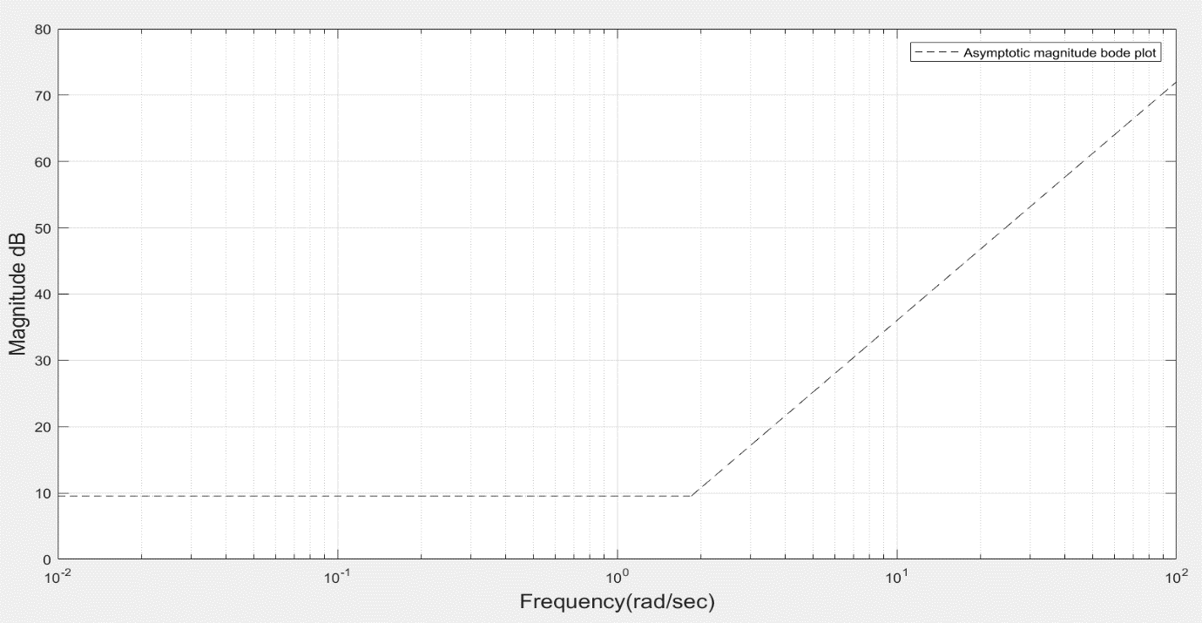

**Figure 3.10- Asymptotic magnitude ode plot of fractional double term zero.**

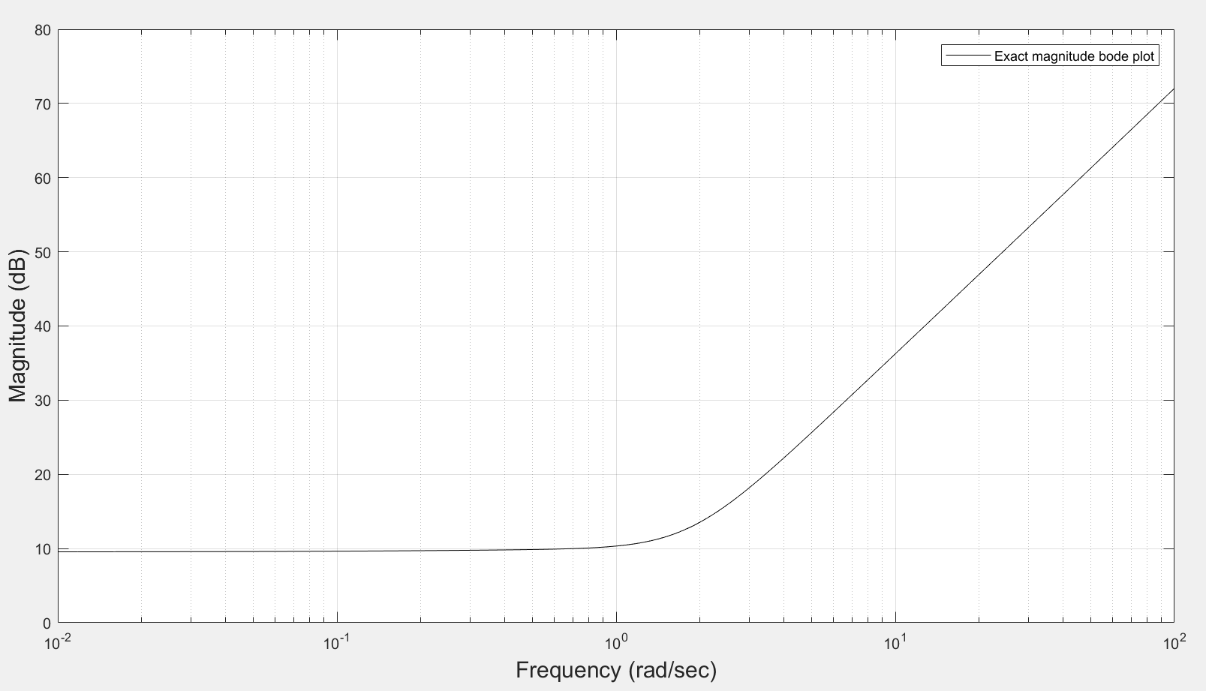

**Figure 3.11-Exact magnitude bode plot for fractional double term zero.**



**Figure 3.12-Exact and asymptotic magnitude bode plot for fractional double term zero.**